

**Group Members:**

**Ahad Bin Ilyas R#161103**

**Owais Ali Raza R#161106**

**Saifullah Butt R#161114**

**Muhammad Bilal#161121**

**Samiullah Butt R#161138**

**Sprint 0 – Software Engineering**

**Submitted To: Ma’am Atka Ali**

**Table of Contents:**

1. User Story Mapping
2. Product Backlog
3. Domain Model

**User Story Mapping**

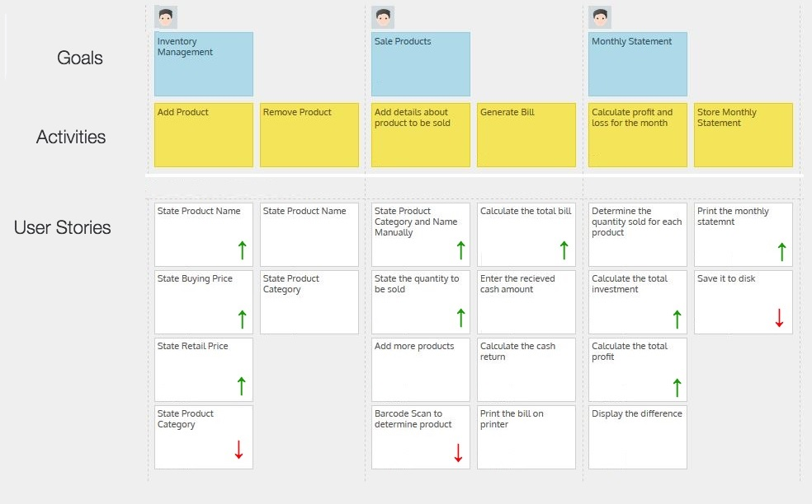

**Product Backlog**

* Login
* Extend Login with Fingerprint
* Product Form - Name, Buying Price, Selling Price
* Product Category Form - Id, Category
* Add Product Form
* Extend adding product with Barcode Scanner
* Remove Product Form
* Billing Form
* Extend billing with Barcode Scanner
* Monthly Statement Form
* Monthly Statement Printing
* Monthly Statement Saving

**Domain Model**

